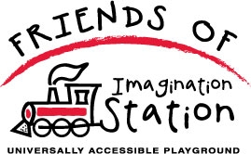

IMAGINATION STATION – UNIVERSALLY ACCESSIBLE PLAYGROUND

IMAGINE...a place where children of all abilities can learn, play, and
grow side-by-side. Come aboard Imagination Station...Waukesha County's first fully inclusive playground where children of every ability can play together!

MAKING THE UNIMAGINABLE POSSIBLE...for some children, delighting in the joys of a conventional playground is unimaginable. When a child uses a wheelchair or has difficulty in walking, climbing a vertical ladder to experience thrill of a slide or traversing gravel on the way to conquering the monkey bars, makes these seemingly simple childhood freedoms unreachable. Imagination Station playground removes these obstacles.

INNOVATIVE FEATURES OF IMAGINATION STATION...rubberized surfacing, recycled plastic composite ramping, therapeutic swings and swinging deck, multi-sensory activity structures, musical and educational components, one entrance/exit safety, and more!

LOCATED...in beautiful Roosevelt Park in Oconomowoc, Wisconsin.

http://www.oconomowocplayground.org/

